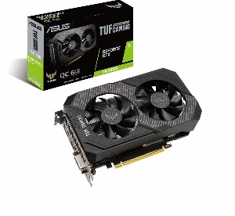

Inner

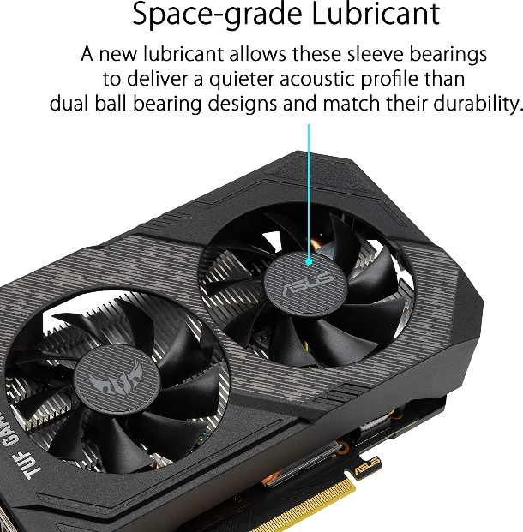

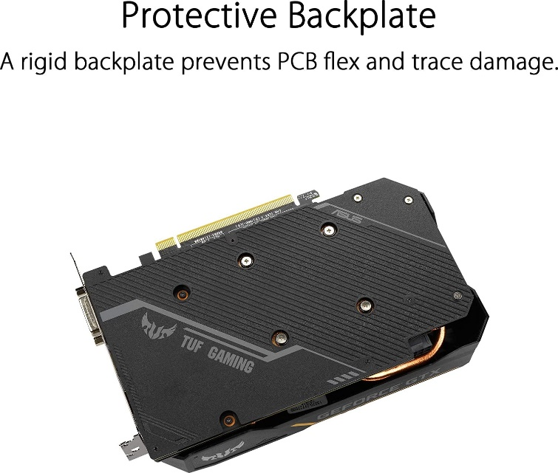





ASUS gddr6 pci_e_x16 TUF Gaming GeForce GTX 1660 Super Overclocked 6GB Edition HDMI DP DVI Gaming Graphics Card (TUF-GTX1660S-O6G-GAMING)

-38% ₹24,900₹24,900

M.R.P.: ₹39,900₹39,900

|  |  |
| --- | --- |
| Graphics Coprocessor | NVIDIA GeForce GTX1660 SUPER |
| Brand | ASUS |
| Graphics RAM Size | 6 GB |
| GPU Clock Speed | 2 GHz |
| Video Output Interface | DisplayPort, DVI, HDMI |

**About this item**

* Powered by NVIDIA Turing with 1845 MHz Boost Clock, 1408 CUDA cores and overclocked 6GB GDDR6 memory in a 2. 7 slot form Factor
* Space-grade lubricant brings the durability of dual Ball bearings to quieter Sleeve bearing designs.
* Gpu Tweak II makes monitoring performance and streaming in real time easier than ever, and includes additional software like Game Booster, XSplit Gamecaster, WTFast and quantumcloud
* Tuf compatibility testing runs cards through a suite of tests to ensure TUF Gaming motherboards, chassis, and other TUF Gaming Alliance components work together flawlessly
* Auto-extreme technology delivers premium quality and reliability using an automated manufacturing process